
(An Autonomous Institution, Affiliated to Anna University, Chennai)
MINI PROJECT
TAMIL NADU 2026 ELECTION RESULT ANALYSIS AND VISUALIZATION USING PYTHON, POWER BI, AND TABLEAU
Framework for Data Visual Analytics

PRITHISH A

241501153
ABSTRACT
This mini project, carried out for the subject Framework for Data Visualization and Analytics (FDVA), analyses the Tamil Nadu Legislative Assembly Election 2026 results using Python, Microsoft Power BI and Tableau. The candidate-level CSV dataset contains results from 234 constituencies and records candidate names, parties, EVM votes, postal votes, total votes and vote share. Python with Pandas is used to inspect the data, standardise column names and data types, check missing values and duplicates, and create analysis-ready tables. Matplotlib and Seaborn are used to visualize party-wise seats, selected party vote shares, seat distribution, candidate counts and key election indicators. Interactive dashboards are designed in Power BI and Tableau to explore party performance and constituency results. Published summaries report 234 constituencies, 4,023 candidates and 86.03% turnout; TVK won 108 seats, DMK 59 and ADMK 47. The project demonstrates how data cleaning and visual analytics can make election results easier to understand.

1. Data Preprocessing
The dataset (tn-results-2026.csv) contains candidate-level Tamil Nadu Assembly Election 2026 results across 234 constituencies. It was inspected and prepared in Python using Pandas, as shown below.

Loading and inspecting the data

df = pd.read_csv("tn-results-2026.csv")
df.shape # candidate-level records and fields in the downloaded CSV
df.info()
The dataset includes constituency number and name, candidate, party, EVM votes, postal votes, total votes and vote share. Numeric fields may need conversion from text to numbers.

Missing values and duplicates

print(df.isnull().sum())
print("Duplicate rows:", df.duplicated().sum())
Check missing values and duplicate records before analysis. Do not assume the number of missing or duplicate rows; use the output from the downloaded file.

Fixing data types and filling missing values

df["Total Votes"] = pd.to_numeric(
df["Total Votes"], errors="coerce")
df["EVM Votes"] = pd.to_numeric(df["EVM Votes"], errors="coerce")
df["Postal Votes"] = pd.to_numeric(df["Postal Votes"], errors="coerce")
df["Vote Share"] = pd.to_numeric(
df["Vote Share"].astype(str).str.replace("%", "", regex=False), errors="coerce")
Vote and vote-share columns are converted to numeric types so that totals and comparisons can be calculated. Missing values should be investigated and handled according to the data source; do not fill official result values blindly.

Standardising text values

df.columns = df.columns.str.strip()
df["Party"] = df["Party"].astype(str).str.strip()
df["Candidate"] = df["Candidate"].astype(str).str.strip()
df["AC Name"] = df["AC Name"].astype(str).str.strip()
df["Party"] = df["Party"].str.upper()
Whitespace and inconsistent party labels are standardised for grouping and visualization. Constituency names and candidate names should be preserved carefully so that official names are not accidentally changed.

Preparing election result fields

df["Total Votes"] = pd.to_numeric(df["Total Votes"], errors="coerce")
df["EVM Votes"] = pd.to_numeric(df["EVM Votes"], errors="coerce")
df["Postal Votes"] = pd.to_numeric(df["Postal Votes"], errors="coerce")
df["Vote Share"] = pd.to_numeric(df["Vote Share"], errors="coerce")
df["AC No"] = pd.to_numeric(df["AC No"], errors="coerce")
The election dataset is constituency-based rather than time-series sales data. Therefore, date conversion is not required; the constituency number is treated as a numeric field and vote measures are checked for valid values.

Creating analysis tables and export

party_summary = df.groupby("Party", as_index=False)["Total Votes"].sum()
party_summary = party_summary.sort_values("Total Votes", ascending=False)
df.to_csv("Cleaned_TN_2026_Election_Results.csv", index=False)
The cleaned candidate-level data is exported for Python visualizations and dashboards. Aggregated tables can be created for party-wise votes, candidate-wise votes and constituency-level results.

2. Data Visualization Using Python
Election results were visualized using Pandas, Matplotlib and Seaborn. The figures below focus on party performance, vote share and constituency-level indicators.
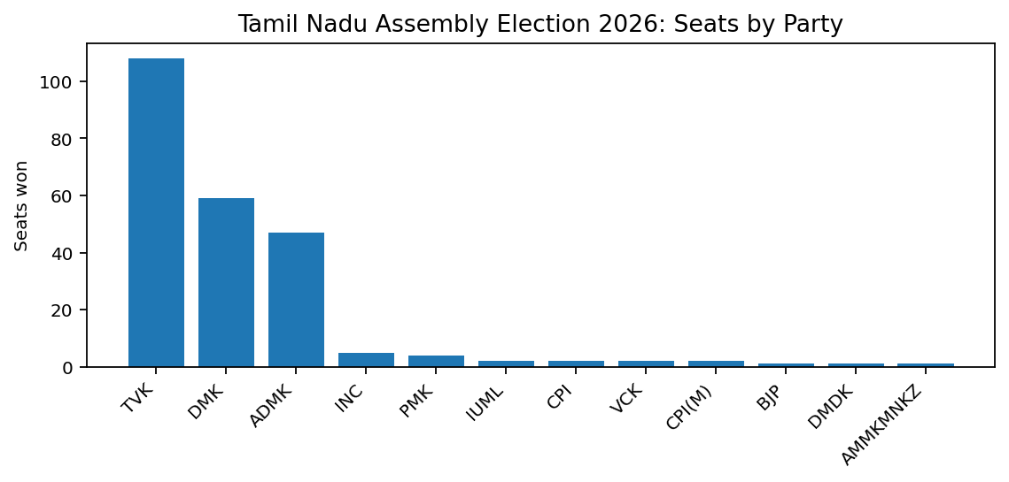
Figure 2.1: Seats won by party (bar chart)
Result: TVK won 108 seats, DMK won 59 and ADMK won 47 out of 234 constituencies.
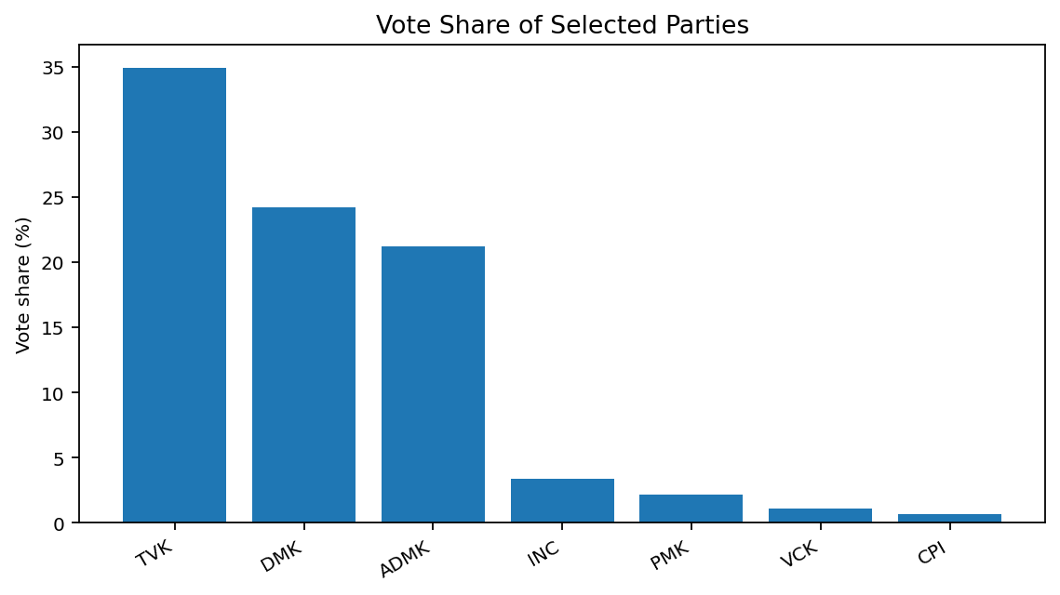
Figure 2.2: Vote share of selected parties (bar chart)
Result: The published summary reports vote shares of 34.92% for TVK, 24.19% for DMK and 21.21% for ADMK.
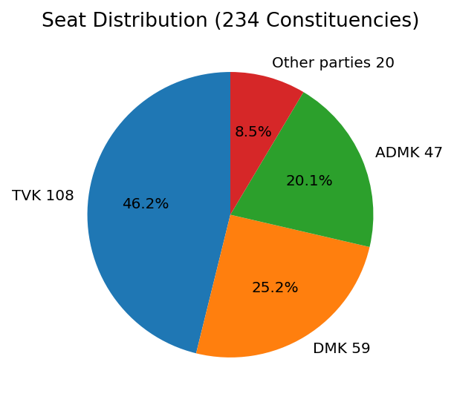
Figure 2.3: Seat distribution across major groups
Result: TVK secured the largest number of seats, followed by DMK and ADMK; the remaining 20 seats were won by other parties.

Figure 2.4: Key election indicators
Result: The election covered 234 constituencies and 4,023 candidates. Reported turnout was 86.03%; NOTA received 199,805 votes (0.41%).
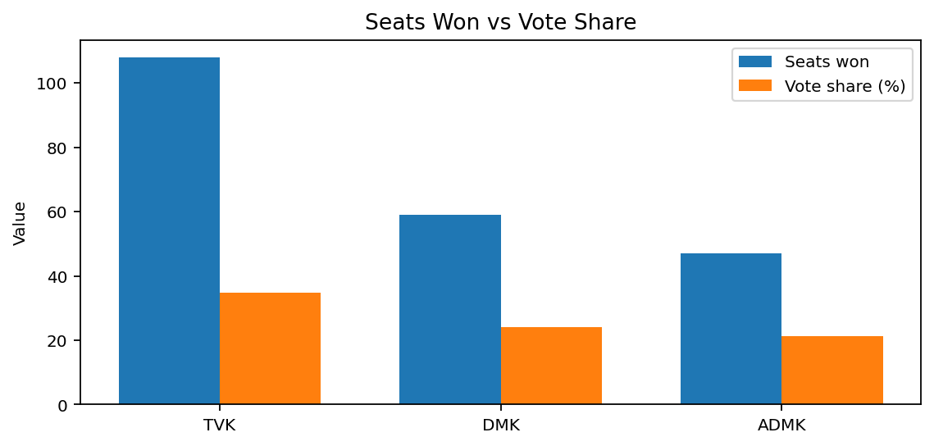
Figure 2.5: Seats won compared with vote share
Result: TVK led both the seat count and the reported vote share among the three largest parties shown.
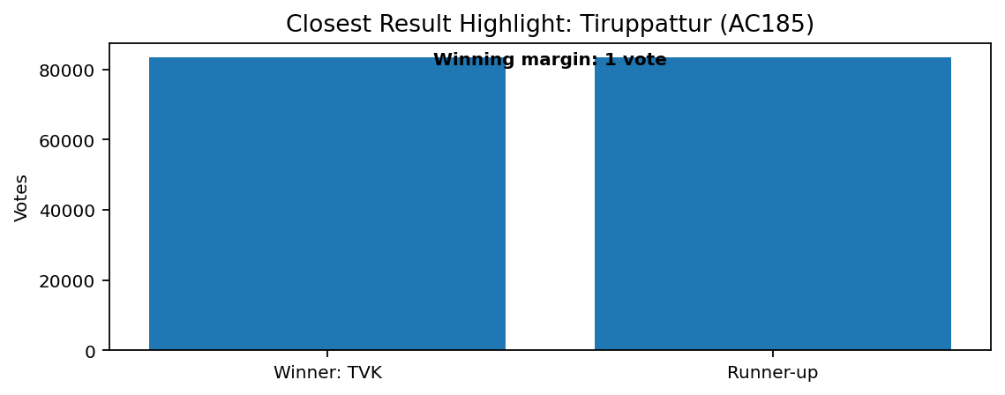
Figure 2.6: Closest result highlight
Result: Tiruppattur (AC185) had a one-vote winning margin: TVK received 83,375 votes and the runner-up received 83,374.
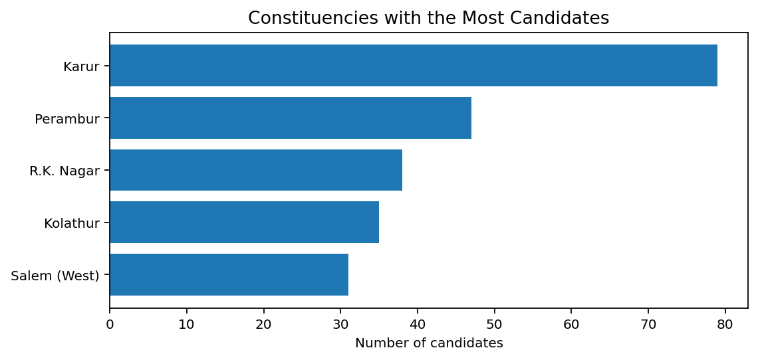
Figure 2.7: Constituencies with the most candidates
Result: Karur had 79 candidates, followed by Perambur (47), Dr. Radhakrishnan Nagar (38), Kolathur (35) and Salem (West) (31).
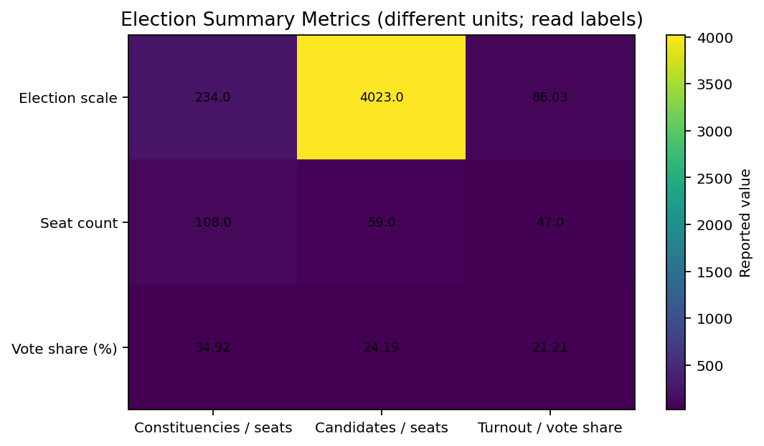
Figure 2.8: Election summary metrics
Result: The summary combines published indicators for constituencies, candidates, seats and vote share. These measures use different units and should be interpreted using their labels.
Overall, the 2026 results show TVK as the largest party by seats, followed by DMK and ADMK. Vote share, seat count, turnout and constituency-level margins provide different perspectives on the election.

3. Power BI Dashboard
Power BI can be used to build an interactive dashboard from the cleaned Tamil Nadu 2026 election results dataset.
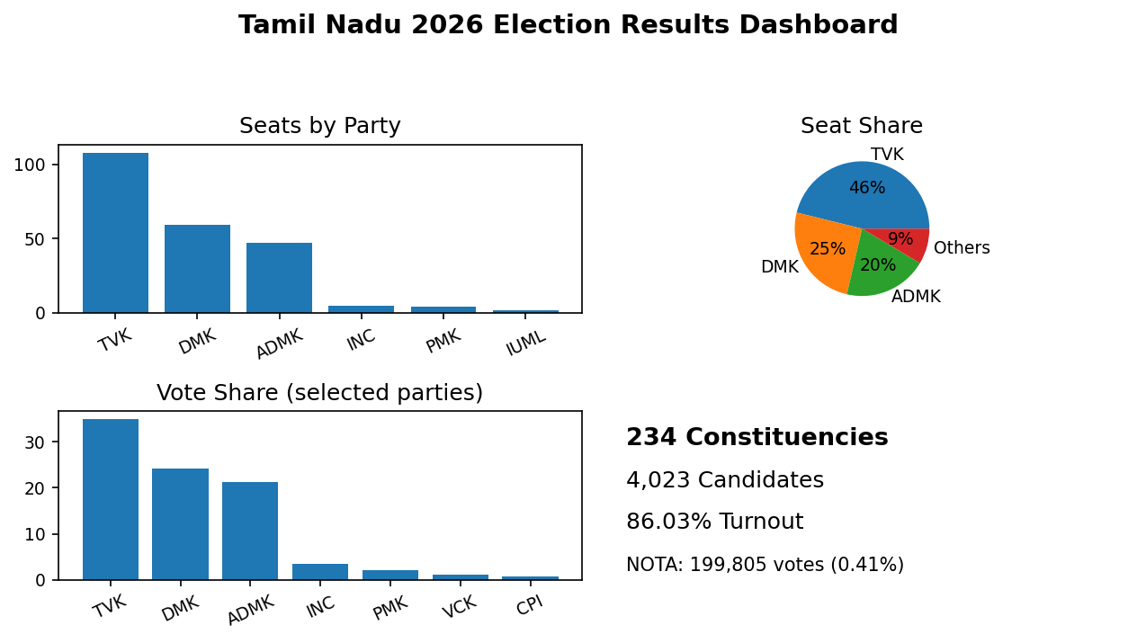
Figure 3.1: Tamil Nadu 2026 Election Results Dashboard in Power BI
- Slicers: Party, constituency name and constituency number can be used to filter candidate and result records.
- KPI cards: 234 constituencies, 4,023 candidates, 86.03% reported turnout and 199,805 NOTA votes.
- Charts: seats won by party, vote share of selected parties, seat distribution, candidate counts by constituency and closest winning margin.
- Insights: TVK won 108 seats, DMK won 59 and ADMK won 47. The closest result highlighted in the published summary was Tiruppattur, decided by one vote.
- Note: Vote-share figures shown are selected-party values from the published summary. Use the full CSV for candidate-level and constituency-level filtering.

4. Tableau Dashboard
Tableau was used to design the “Tamil Nadu 2026 Election Results & Insights Dashboard” from the cleaned election dataset.
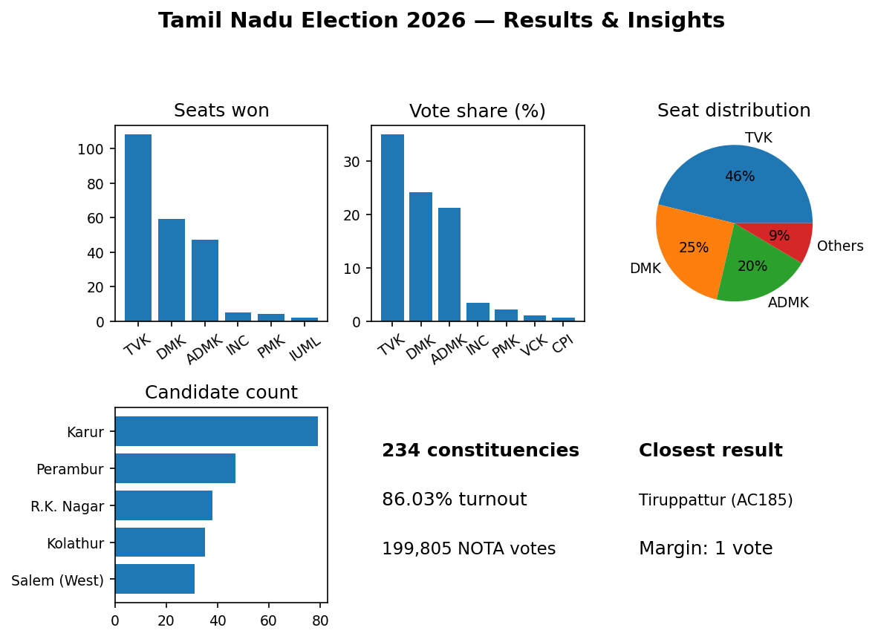
Figure 4.1: Tamil Nadu 2026 Election Results Dashboard in Tableau
- Filters: Party, constituency name and constituency number support interactive exploration of the election results.
- KPIs: 234 constituencies, 4,023 candidates, 86.03% turnout and 199,805 NOTA votes (0.41%).
- Charts: party-wise seats, selected party vote share, seat distribution, candidate counts in constituencies and the closest result.
- Insights: TVK won 108 seats, DMK 59 and ADMK 47. Karur had the highest number of candidates among the examples shown, while Tiruppattur had a one-vote winning margin.

